Rodrigo Rodriguez

07/05/2024

Applied Data Science

DSC680 (SUMMER)

**Project Whitepaper Draft: Analyzing Marketing Lift of a Targeted Local Campaign**

**Business Problem**

WM (Waste Management) ran a local marketing campaign in the month of May targeting specific zip codes. The marketing team now needs to report on the lift that advertising had to online orders. This project aims to analyze historical order volumes for the targeted zips to establish an estimated baseline of orders expected to be received during the campaign period without advertising. The baseline will be used to calculate lift by observing actual orders minus the baseline orders.

**Background and History**

WM is a company with a long history. However, recently the company has been trying to push more sales to the online channel since it is a lower cost channel. Offline order conversion incurs higher cost to process due to involving live sales or customer support agents. Advertising is accepted to play a pivotal role in generating demand. The majority of marketing campaigns are done at a national level with very few campaigns targeting local areas. This campaign will be seen as a test pilot to examine the effectiveness and feasibility of scaling the local campaign strategy.

**Data Explanation**

The data is a simple dataset with only the features needed for the time-series analysis with data ranging from 5/31/21 to 5/27/24. There is a date column which was set as the index and four integer columns that contain the count of orders for a given date. However, we will only focus on one of the four integer columns for this analysis, “IS_ORDER_CONFIRM_IND_SUM”. This feature contains the total number of orders across all lines of business for a given date. The data was obtained from internal WM systems and was pulled, plus transformed, in a Snowflake SQL environment. The transformation done was the aggregation of daily records to weekly records. Seasonality is present at the daily level with weekends having low sales volumes and Monday having large sales volume. Aggregating to weekly level removes the daily seasonality.

**Methods**

During EDA the time-series data was plotted, and a seasonal component was observed in the data. As highlighted in Figure (1), there are large spikes of sales volumes starting in Spring and ending Fall. This seasonality follows a normal industry sales cycle. Descriptive statistics for the data revealed 157 weekly records, a mean weekly order volume of 22, and a weekly order volume standard deviation of 8.3. Since the dataset displays yearly seasonality, I will focus on a SARIMA model for this project since this model works specifically well for data with seasonality present.

Figure 1

2023

2022

**Analysis**

The SARIMA model's performance was measured by MAE, and MSE. I mainly focused on a SARIMA model but decided to also test ARIMA and Exponential Smoothing for comparison. When comparing the performance metrics against the three models it becomes clear that the SARIMA model was the best fit for this dataset based on MSE. Figure (2) displays Here are the performance metrics for each model:

* ARIMA MAE 15.47
* ARIMA MSE 289.83
* Exponential Smoothing MAE 4.86
* Exponential Smoothing MSE 27.7
* SARIMA MAE 25.11
* SARIMA MSE 4.1

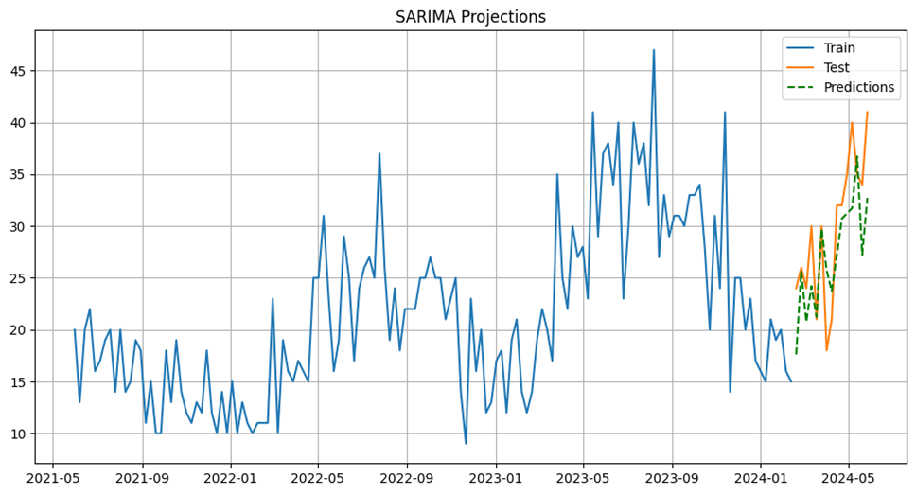

Figure 2

**Conclusion**

While both the SARIMA and Exponential Smoothing models both appear to be good options at first glance, it’s important to consider both statistical metrics and the contextual factors influencing the data. Advertising ran during the test dates, meaning that a higher MAE for the SARIMA contextually makes sense. The SARIMA’s lower MSE indicates that the model is generally stable and not making extreme errors.

**Assumptions**

We assume that advertising has an effect on orders. Additionally, we assume that no other external factors (such as competition) are affecting the performance of the model during the test period.

**Data limitations**

The data does not include exogenous variables (in this case marketing campaign variables). This limitation ruled out the use of a SARIMAX model, which would have helped the model account for the external factors and potentially improve accuracy.

**Challenges**

Primary challenges include the presence of advertising during the test period and lack of exogenous marketing variables. The presence of advertising during the test period does not allow us to understand how well the model performs under normal circumstances (before the campaign. In the future the period used to test the model should only include normal circumstances to better understand model performance.

**Future Uses and Recommendations**

This project has the potential to be scaled to multiple instances of similar campaigns. For example, if a similar campaign were to be launched across fifty local targeted areas, then this code could be used to establish a baseline and calculate lift by comparing predictions to actual data for each local area. My recommendations for the future are to exclude the presence of advertising during the model’s test period and to include marketing variables to implement a SARIMAX model.

**Implementation Plan**

It is possible to leverage one of the above recommendations immediately in the implementation plan. The training period of the model can be reduced to ensure that the test period is under normal circumstances (before the marketing campaign). This step would further validate the choice of model, cause the performance metrics to be evaluated without any additional context. Once this recommendation is made the implementation will consist of adjusting the targeted zips in the SQL code used to pull the dataset, and then re-run the cleaning/modeling phase for subsequent campaigns.

**Ethical Assessment**

Clearly communicate the model’s limitations and assumptions to stakeholders. Any business decisions made from the results of the model should be done so ethically and not exploit customers or lead to unfair practices.

**Potential Audience Questions**

1. How was the data split between the training and test sets
2. Why were SARIMA and Exponential Smoothing chosen as the primary models for comparison?
3. How did the advertising campaign affect the order patterns during the test period?
4. Can you explain the significance of the MAE and MSE metrics in evaluating model performance?
5. Why did the Exponential Smoothing model show a lower MAE but potentially overestimate orders?
6. How do you plan to incorporate the advertising campaign data into future models?
7. What steps were taken to ensure the models are not overfitting the training data?
8. How reliable are the model predictions for future periods without advertising campaigns?
9. What other external factors might influence order patterns and how are they accounted for in the models?
10. How will the calculated marketing lift be used to inform future advertising strategies?

**Sources/Appendix**

Shapiro, G. P., & Masand, B. (1999). Estimating Campaign Benefits and Modeling Lift. *KDD99: The First Annual International Conference on Knowledge Discovery in Data*, 185-193. https://dl.acm.org/doi/10.1145/312129.312225

Jaffery, T., & Liu, S. X. (2009, March). *Measuring campaign performance by using cumulative gain and lift chart*. In SAS Global Forum (Vol. 19). https://scsug.org/SCSUGProceedings/2008/papers/app/Tariq_Jaffery_and_Shirle_%20Liu.pdf

Pratt, S., McCabe, S., Cortes-Jimenez, I., & Blake, A. (2010). *Measuring the Effectiveness of Destination Marketing Campaigns: Comparative Analysis of Conversion Studies*. Journal of Travel Research, 49(2), 179-190. https://doi.org/10.1177/0047287509336471